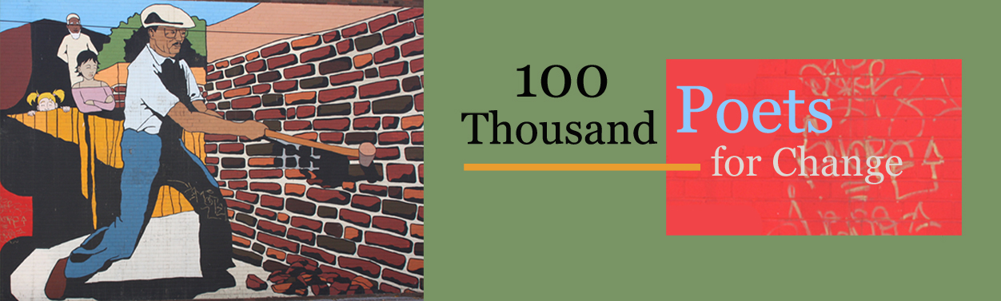

A Global Event — September 24^{th,} 2011

Poets around the world are planning individual events to take place simultaneously on September 24th in a demonstration/celebration of poetry to promote social and political change.
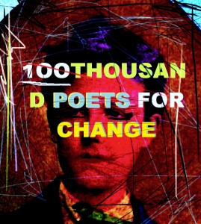So far, 132 US cities representing 35 countries have signed up to make this global initiative a success through poetry readings, political demonstrations, community picnics, awareness events, parades, and more!

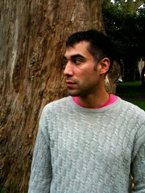The Seattle location is SPLAB: 36th & Edmunds in the former Columbia School. Cedar Sigo reads at 8P and facilitates a workshop from 3-6P on the San Francisco Renaissance (Joanne Kyger, John Weiners and Jack Spicer) and will feature Ted Berrigan’s blueprint for a poem to be written spontaneously.
Join Us! 11:30A – 11:30P

San Francisco poet Cedar Sigo was born February 2, 1978. Raised on the Suquamish reservation near Seattle, he was home schooled from the eighth grade onward. In 1995 he was awarded a scholarship to study writing and poetics at The Naropa Institute in Boulder Colorado and studied with Allen Ginsberg, Anne Waldman, Lisa Jarnot, Alice Notley, Joanne Kyger & other poets. A San Francisco resident since 1999, his 2nd collection Stranger In Town is just out from City Lights.

