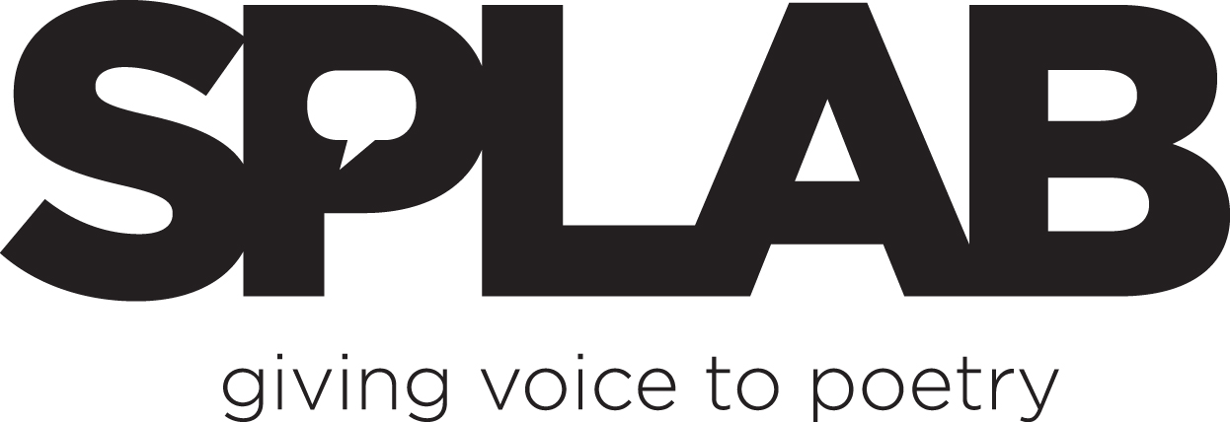

Contact: Paul Nelson FOR IMMEDIATE RELEASE
Tel: 206-422-5002
E-mail: pen@splab.org

CASCADIA POETRY FESTIVAL TO BE HELD MARCH 24-25 IN SEATTLE
Event Includes Workshops, Readings, and Panels with Northwest US and Canadian Faculty

Seattle, WA, December 30, 2011—The Cascadia Poetry Festival seeks to examine the culture of this region by gathering poets from California, Oregon, Idaho, Washington, British Columbia, the Alaska panhandle and Western Montana to learn, share ideas and techniques, begin to discover the qualities of this bioregion and the possibilities for deeper connection between the inhabitants from all parts of the region. On March 24 and 25, 2012, renowned and emerging poets from the region will present talks on Cascadian culture and illustrate how that is presented in the best poetry of the region..

Featured artists include Sam Hamill, Judith Roche, Tim McNulty, Dan Raphael, Carolyne Wright, Kim Goldberg, Trevor Carolan, Catherine Owen, Maleea Acker, Katharine Whitcomb, Richard Olafson and others. Complete biographies can be found online at www.splab.org/cascadia.

The festival opens on Saturday, March 24 with a faculty-led discussion from 9:00-11:00am at SPLAB, 3651 S. Edmunds in Seattle. Workshops follow in the afternoon, including a nature walk and writing prompt from 12:00-4:00pm: Igniting the Green Fuse: Women on Eco-Poetry moderated by Kim Goldberg (Nanaimo, BC) at Seward Park Environmental and Audubon Center. Workshops by Tim McNulty (Sequim, WA) and Dan Raphael (Portland, OR) will also be held at SPLAB that afternoon. A keynote reading will take place at SPLAB at 7:30pm.
On Sunday, March 25, the day opens again with a faculty-led discussion from 9:00-11:00am at SPLAB. Judith Roche (Seattle, WA) will lead a workshop on The Power of Place from 1:00-3:00pm. At 4:00pm, selected readers from Introducing A Sense of Place: The Washington State Geospatial Poetry Anthology will read at SPLAB, and an evening reading will follow.
All times, locations, and participants are subject to change. Please watch the SPLAB web site for up-to-the-minute scheduling changes. Fees: All Access Gold Passes are available for $50 and get festival attendees into all weekend events. Passes may be purchased in advance through the SPLAB web site, or by contacting SPLAB at 206-422-5002. Individual workshops are $20, and all readings are a suggested donation of $5. Morning faculty-led discussions are open to Gold Pass holders and faculty members only.
This event is co-sponsored by Pacific Rim Review of Books, Humanities Washington & Seward Park Environmental and Audubon Center. SPLAB is an intergenerational writing, performance, resource and outreach center. Founded in 1997 in Auburn, Washington, by poets Paul Nelson and Danika Dinsmore, SPLAB’s office is now located Seattle's Columbia City neighborhood. SPLAB hosts a weekly writer's critique circle, Living Room, every Tuesday at 7pm, at 3651 S Edmunds in Seattle. For more SPLAB event information, visit www.splab.org.
###

For information or to arrange interviews with faculty, contact Paul Nelson at 206-422-5002.

