20 THEHOLLYWOODSTARNEWS WWW.STAR-NEWS.INFO:SERVING NORTHEAST AND NORTH PORTLAND
NEIGHBORHOODS SEPTEMBER 2015 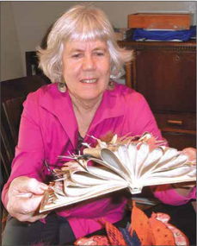
BEAUTIFUL BOOKS Artist and writer Marilyn Stablein creates unique, handmade art objects. PAGE 20
Marilyn Stablein makes art in form of books
By Janet Goetze
For the Hollywood Star News
Marilyn Stablein is an award-winning writer who has lived in six states plus India and Nepal. Now a Northeast Portland resident, she also is an artist, working in collage and artists’ books that have been shown nationally and internationally.
Artists’ books are an art form that dates from the 1960s in the United States, although they appeared in various forms earlier in Europe. They aren’t typical tomes, of course,
“They are art in the form of a book,” said Laura Russell, who owns the 23 Sandy Gallery, 623 N.E. 23rd Ave., one of the few galleries in the country devoted to artists’ books.
They may be made from a variety of materials. Some are created with accordion folds, others with flags that unfurl when the book is opened, and still others are arranged in boxes that close like a book. Some start as traditional books that are altered with folded pages, or pages cut into shapes or butterflies and flowers added to bowed pages, as Stablein has done with one book.
The binding is sometimes the artistry in a book. Stablein created one with
a vintage silk stocking bag which, she noted, is already bound.
In short, the artist book is a unique art object, Stablein writes in her new book, “Bind, Alter, Fold,” which is all about her art books. It’s a conventional book with a colorful photograph of an artist book on the cover. Stablein describes it as a 90-page art catalog with 80 full-page color photographs of her handmade artist books. It is available for $28 on her website, marilynstablein.com.
Stablein will teach an introductory class in artist books through Mountain Writers from 9:30 a.m. to 12:30 p.m. November 14, 21 and 28 at the Multnomah
Friends Meeting House, 4312 S.E.
Stark St. Enrollment information is at mountainwriters.org. The fee is $150.
“With all the e-books and other de- emphasis on books,” she said, “people are more interested in unique and hand- made books.”
Stablein was born in Los Angeles and started college in the 1960s at the University of California at Berkeley. After her freshman year, she planned a summer trip to Paris. She stayed for a few more months in Europe then decided to go on to India and eventually to Nepal over
Marilyn Stablein created an artist’s book by altering a conventional book with bowed pages where butterflies and flowers alight. Interest in artists’ books has been growing since the 1960s. (Janet Goetze)
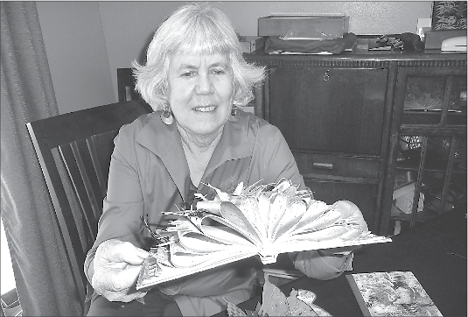
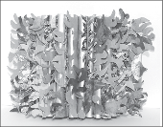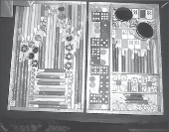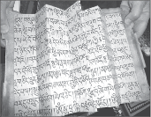
the next half-dozen years. She painted, studied culture, learned to read and
write two Tibetan calligraphy scripts and collected some of the items that appear in her various artworks.
Several years after returning to the United States, Stablein earned a degree
in creative writing from the University of Washington in 1981. One of her books, “Sleeping in Caves,” is a memoir from
her years in the Himalayas where, among other adventures, she met the Dalai Lama.
She has received grants to assist her literary work, which includes essays, fiction and poetry. She received the New
Mexico Book Award in 2010 for “Splitting Hard Ground,” a book of poetry, and the National Federation of Press Women poetry book award in 2011.
Stablein created her first book in India to record dreams. She purchased handmade paper and held the pages together with stitches on the left side. Later, she learned it was simplified Japanese stab binding.
About nine years ago, she took a workshop in Seattle with Hedi Kyle, a New York state resident who is at the forefront of the artist book movement, according to Russell.
“The folded books and the new forms
Hedi Kyle developed appealed to me,” Stablein said. She has since gone on to create flag books, a style attributed to Kyle. When the book is opened, small “flags” with designs or information wave from the pages.
Stablein also has books with tickets, programs, invitations and other ephemera that form a memoir of a period in her life or a particular trip.
“I keep written journals, too, but this is primarily visual,” she said. “It’s like a time capsule.”
Another book artist, Ellen Ziegler of Seattle, said, “It’s very compelling to mix this art form with language — to mix text and craft, text and visuals. Sometimes what speaks to you is the form itself.”
Some of Stablein’s books are created in limited editions and some are one of a kind. Collectors have discovered the art form, she said. Museums and universities with rare book rooms also purchase artist books, Russell said.

